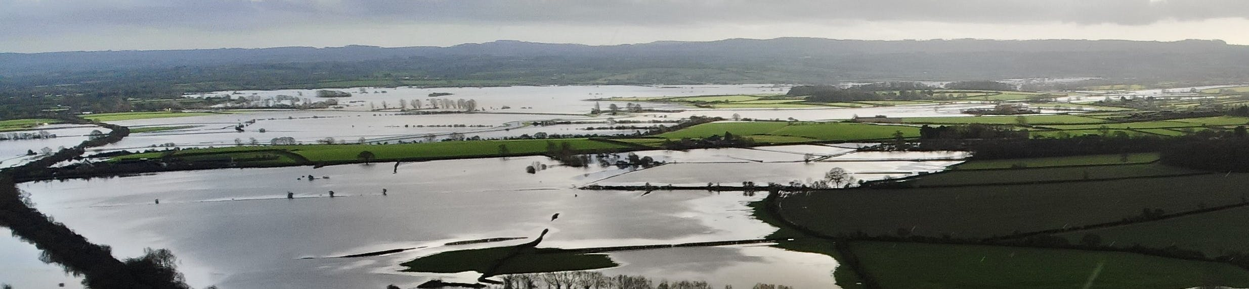

Somerset Flooding 2026 – Summary of Events, Impacts and Ongoing Actions
1. Overview of the Flooding Event Somerset experienced the second wettest January and February on record, with more than double the usual rainfall. Storm Chandra delivered around one-third of January’s rainfall in a single event, pushing 1.2 million cubic metres of water per hour through the Parrett and Tone catchments. Approximately 30 square miles of agricultural land on the Somerset Levels and Moors were flooded. A major incident was declared on 27 January by Somerset Council, supported by the Environment Agency (EA) and Local Resilience Partners.
2. Impact on Communities • 2,860 properties were protected by flood defences. • Temporary pumps prevented flooding to around 180 homes and businesses. • Between 80 and 90 properties flooded across Somerset, including around 20 on the Levels and Moors.
3. Environment Agency Response The EA mounted a large multi-agency response, bringing in staff and equipment from across the country. Key actions included: • Deployment of additional pumps to 19 locations, including 28 ultra-high-volume pumps. • Reprofiling of riverbanks to improve water flow. • Removal of channel restrictions and construction of temporary bypass channels. • Operation of the Parrett Flood Relief Channel (Sowy/King’s Sedgemoor Drain) at higher flows than in previous events. • 24/7 on-the-ground staff monitoring assets and maximising pump use. • Community drop-ins, briefings and high-volume enquiry handling.
4. Public Safety and Guidance Residents were advised not to walk or drive through floodwater due to depth, contamination and hidden hazards. The EA provides guidance on preparing for flooding, river and rainfall monitoring, flood warnings, and recovery support. Flooding can be reported via: • EA Incident Hotline: 0800 80 70 60 • Somerset Council • Flood Online Reporting Tool (FORT) for non-emergency reporting
5. Recovery and Review (May 2026 Update) • Over 1,700 flood-defence assets have been inspected across Wessex, with further inspections planned. • Additional funding is being sought for repairs. • A bypass culvert at Viney’s Bridge is nearing completion to improve flows to Northmoor Pumping Station. • A Section 19 investigation is underway for Bathpool following internal property flooding. • County-wide review of flood information, defence performance, pump deployment triggers and feasibility of permanent pump infrastructure. • Flood-extent data is being collected to support future flood-risk management. • Ongoing engagement continues through Local Community Network meetings and Somerset Rivers Authority board meetings.
6. Operational Updates (February–March 2026) • Pump demobilisation is underway as water levels recede. • Road closures have been required for pump removal at West Yeo Road, Huntworth Lane and Elson’s Clyce. • By mid-March, no Flood Warnings remained in place, though some Flood Alerts continued. • Many temporary pumps are no longer required as drain levels return to normal winter levels. • Standing water remains on fields until it drains or soaks away. • Public meetings and multi-agency drop-ins have been held, including events for Bathpool residents.
7. Key Contacts Floodline: 0345 988 1188 Environment Agency Incident Hotline: 0800 80 70 60 Somerset Council: 0300 123 2224
If you want, I can also produce a shorter public notice, a poster version, or a Word-ready layout with headings and spacing.

