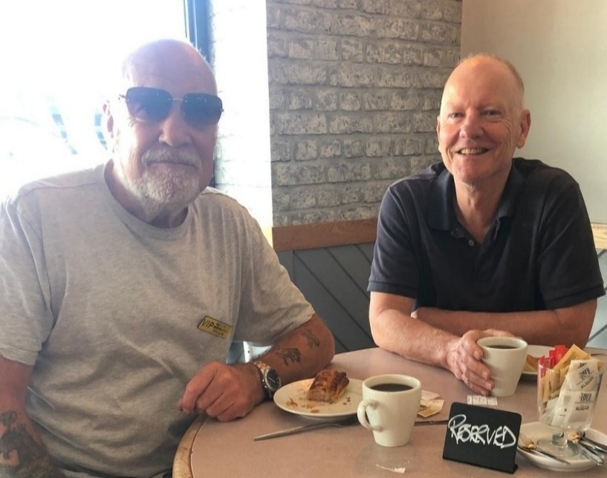
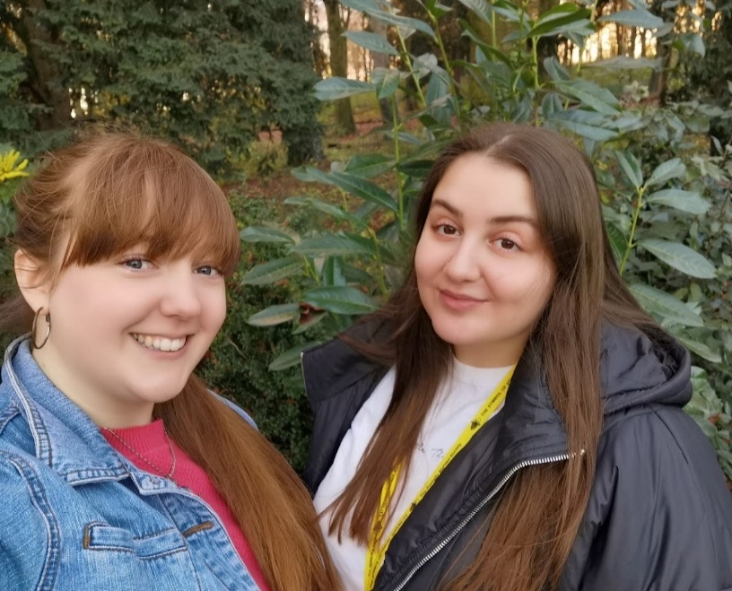


RECRUITING VOLUNTEERS IN YOUR LOCAL AREA

Somerset Sight seeks volunteers to provide regular befriending to people with sight loss in your area. This is a fun and rewarding role suitable for all ages. The greatest reward is to help someone to enjoy life more fully.

You will learn skills, meet people and join our thriving team.

“It's a pleasure to be able to help a real person and make a difference to their life. I enjoy our time together so much”

“My volunteer means the world to me, gives me joy and happiness and things to look forward to.”

Full training, ongoing support and reimbursement of reasonable expenses.

Other volunteer roles are available so please contact Somerset Sight on 01823 333818 or email admin@somersetsight.org.uk

The recruitment process is quick and straight forward. We look forward to hearing from you

Head Office Address: Northfield House, 51 Staplegrove Road, Taunton, Somerset, TA1 1DG.
Tel: 01823 333 818 | www.somersetsight.org.uk
Registered charity number: 1154472 | Company number: 8432686

