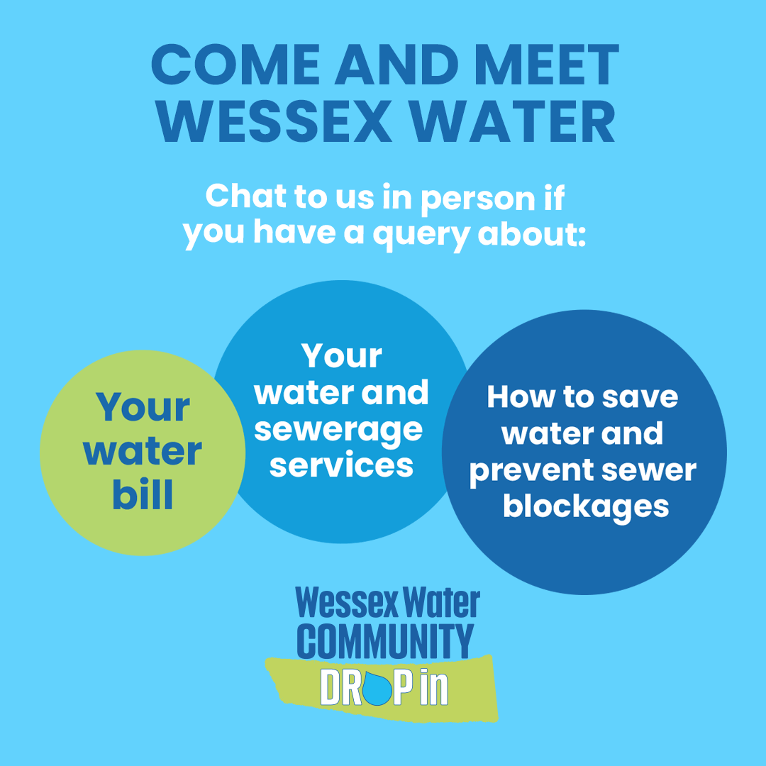

Wessex Water is holding sessions across our supply area to give customers the opportunity to speak with us face to face about anything water-related—whether it’s bills, supply, wastewater, or support for those struggling with payments. I’ll be on hand to offer advice and explain the help available.

I’m pleased to announce that I’ll be hosting a community drop-in session on:

📍 Tuesday 28 April

🕑 10am-12pm and 1pm-2pm

📌 Bridgwater Library, Kings Square, Bridgwater TA6 3AR- Enter through rear of the building on Northgate

I’ve attached an image for you to share on social media. Please feel free to use the text below. Posters will also be distributed around the area —if you’re able to display one, just let me know.

If you think your community would benefit from a visit—whether to answer questions, address concerns, or speak with a local group—please don’t hesitate to get in touch.

Suggested Social Media Post (Facebook/Instagram):

Starts

💧 Do you have a query about your water bill, how to save water and prevent blockages, or your water and sewerage services?

@wessexwater will be holding a drop-in session at Bridgwater Library, Kings Square, Bridgwater TA6 3AR- Enter through rear of the building on Northgate on Tuesday 28 April to answer all of your water related questions.
The session will run between 10am-12pm and 1pm-2pm.

👉 To find out more, visit: https://www.wessexwater.co.uk/community-drop-ins

Ends

Thanks for your support.
Kind regards,

Mark

Mark Bell
Community Outreach Coordinator



Wessex Water
Operations Centre, Claverton Down, Bath BA2 7WW

Email mark.bell@wessexwater.co.uk
Mobile 07500033500
Web ytl.com | wessexwater.co.uk



