Westonzoyland Parish Council wish to bring the following public consultation to your attention.
The Environment Agency have determined that Towens of Weston Ltd must apply for a variation to their Environmental Permit EPR/HB3004KS as part of their requirement to allow them to operate their Matec Aggretec 150 Wastewater Treatment and Filter Press, Washing and Classification plant at their site off Springway Lane, Westonzoyland. There is currently a stop notice preventing use of the wash plant.
Towens increased their waste throughput for the site from 50,000 to 200,000 tonnes a year on their permit earlier this year. There does not seem to have been any public consultation on this variation V002.
There is now a public consultation for a variation to their permit to allow use of the wash plant to which you can respond. The consultation closes by 30th December 2025 leaving just over 2 weeks, and can be accessed here: https://consult.environment-agency.gov.uk/psc/ta7-0js-towens-of-weston-ltd-epr-hb3004ks-v003/
The only things that you can comment on are:
- Relevant environmental regulatory requirements and technical standards – you can read the documents that Towens have sent to the Environment Agency on the Citizen Space website.
- Information on local population and sensitive sites – the site is around 60m away from our Langmead and Weston Level Site of Special Scientific Interest, is within 100m of the homes of those living on the Airfield Camp / Springway residential area and within 200m of the businesses on Springway Business Estate. It is under the flight path for Westonzoyland Airfield.
- Comments on whether the right process is being used for the activity, for example whether the technology is the right one – this is quite technical!
- The shape and use of the land around the site in terms of its potential impact, whether that impact is acceptable and what pollution control or abatement may be required – you may be aware of the effectiveness of the measures that have been in place over the last 2 years while the wash plant has been operating so may wish to comment on this.
- The impact of noise and odour from traffic on site – you cannot refer to traffic going through the village for an environmental permit consultation.
- Permit conditions by providing information that the Environment Agency have not been made aware of in the application, or by correcting incorrect information in the application if there is any (e.g. monitoring and techniques to control pollution).
This is link to a publicity page that describes the wash plant that was installed on the site (2022-2023) https://www.matecindustries.com/en/case-study-towens-plant-wastewater-treatment-sand-washing/. There is a video at the bottom that explains the way in which the wash plant works and the type of wastes that it can be used to treat.
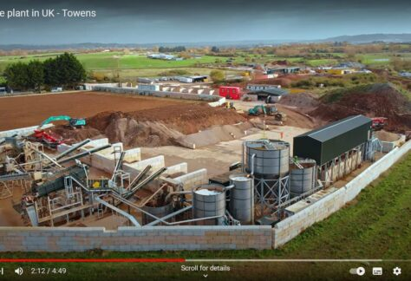
Complete plant in UK Towens
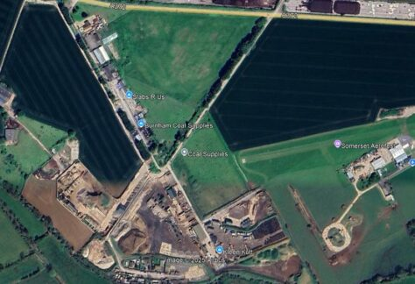
Google Earth satellite view 2025 shows the Towens site and wash plant south of the A372
We anticipate that Towens will also need change in their existing planning conditions by submitting a planning application to Somerset Council before the site can store, process and treat this volume of soil and other types of waste or use the wash plant, but there is no planning application in the public domain for you to comment on yet.
Download Springway Statement on Judicial Review
Copyright © Westonzoyland Parish Council

